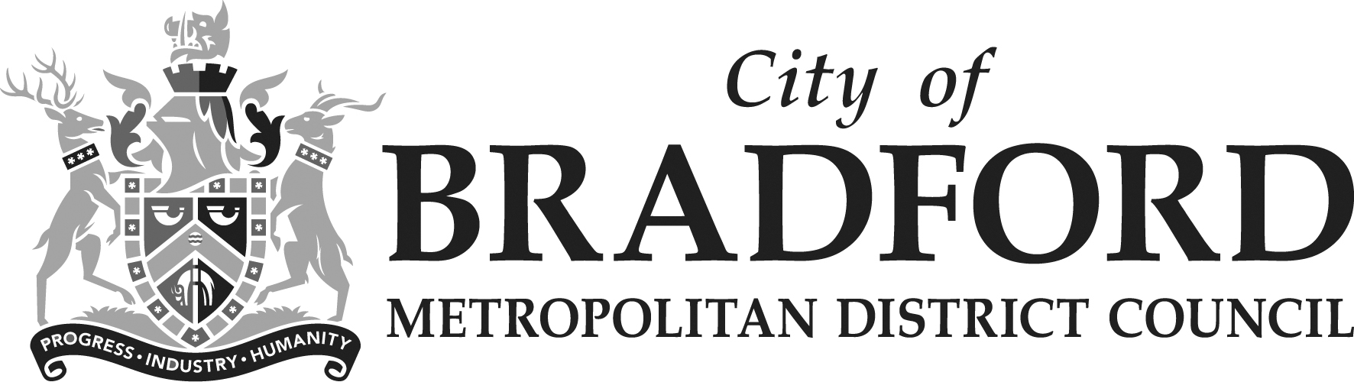

Equality Impact Assessment Form Reference –

Department | PLACE | Version no | 0.1
Assessed by | Noreen Akhtar | Date created
Approved by |  | Date approved
Updated by | Jonathan Hayes | Date updated | 23/02/24
Final approval |  | Date signed off

Please keep a record of when updates are made and who has made them. Final approval should be given when the EqIA is published. A referencing system will be in place for annual budget changes, but outside of this, you should use your service’s own reference. The reference should remain the same from initial proposal through to implementation and on going reviews. Please remember this form ONLY needs completing if you have decided there are impacts (positive or negative) on people. If there are no impacts then this should be recorded in a publicly available format (e.g. a committee report) with a summary of why you have reached this conclusion.

The Equality Act 2010 requires the Council to have due regard to the need to
- eliminate unlawful discrimination, harassment and victimisation;
- advance equality of opportunity between different groups; and
- foster good relations between different groups

Section 1: What is being assessed?

1.1 Name of proposal to be assessed.

This proposal is to reduce the numbers of staff in the Stronger Communities team.

1.2 Describe the proposal under assessment and what change it would result in if implemented.

The proposal is to rationalise current activities within the Stronger Communities Team, and to reduce the numbers of staff who directly deliver this service through supporting the community, faith, and voluntary sector to deliver and coordinate local delivery in localities.

The post of Stronger Communities Co-ordinator (District Lead) would be retained in order to continue to provide strategic leadership and governance support to the Council and partners.

The retained District Lead would offer strategic support rather than manage direct operational delivery.

Area teams will take on the responsibility to support new and emerging groups at an area and Neighbourhood level.

Area teams will take on the responsibility to support less represented Communities of Interest and this will be set out in locality planning.

This delivery model would replicate/revert back to a way of working in the NCS prior to the externally funded integration pilot in 2018.

Section 2: What the impact of the proposal is likely to be

  - Will this proposal advance equality of opportunity for people who share a protected characteristic and/or foster good relations between people who share a protected characteristic and those that do not? If yes, please explain further.

Equality of opportunity will continue to be supported, but through a different delivery model.The Area teams which include Youth Servcies have a wealth of proven expereince and indepth knolwedge of the communities they work with. The Stronger communities team has been in exhistance for just over a year, the past year they have taken the time to embed and establish relationships.

The Area offices and Youth work teams are qualified and expereinced in community engagment and community development, on par with the experience and knowledge required of those in the Stronger Communites team.There will be a need to refocus from a neighoburhood based appraoch to a district focus in some instances, this is on par with the role of the Stronger communites team who also had a neighbourhoods focus in their role.
Whilst a mitiagtion is not a replacement for a specifc team, it will alllow prioritisation of pieces of work that may otherwise have halted in itsentirety impacting negatively on some less well established communities.

  - Will this proposal have a positive impact and help to eliminate discrimination and harassment against, or the victimisation of people who share a protected characteristic? If yes, please explain further.

Some elements of this work have always been embedded into the work of the NCS both in district and area teams the collective work of the NCS has over time had a very positive impact on eliminating discrimination and victimisation as this has been a key focus of not just the SCT team but the servcie.. This will continue, although the proposal is to change the delivery model, and reprioritise work.

  - Will this proposal potentially have a negative or disproportionate impact on people who share a protected characteristic? If yes, please explain further.

Yes. The work of this team has produced counternarratives to extremist ideologies reducing tensions between communities and creating platforms for communities to engage in constructive dialogue.

The proposal is likely to impact all communities of Bradford but particularly BME, new and emerging communities and will also impact communities of Muslim faiths who are subject to Islamophobia however the faith sector is strong, well establsihed and resilliant in how it connects and co-produces. The work with LGBTQ and disability groups was just beginning and could be impacted

The team has a specific focus on supporting new and emerging communities, representative groups who share protected characteristics, and progressing the aims and actions in the Stronger Communities strategy which is about integration and cohesion.

  - Please indicate the level of negative impact on each of the protected characteristics?

(Please indicate high (H), medium (M), low (L), no effect (N) for each)

Protected Characteristics: | Impact  (H, M, L, N)
Age | L
Disability | M
Gender reassignment | M
Race | H
Religion/Belief | H
Pregnancy and maternity | L
Sexual Orientation | M
Sex | L
Marriage and civil partnership | L
Additional Consideration:
Low income/low wage | L
Care Leavers | L

2.5 How could the disproportionate negative impacts be mitigated or eliminated?
(Note: Legislation and best practice require mitigations to be considered)

Prior to this team being established within the last 18 months (with an additional base budget uplift), the Stronger Communities Co-ordinator and the wider teams of the Neighbourhood Service worked with front line communities and locality VCS partners. This proposal would assume this previous method of delivery.

The work of the team will be blended into the area teams, with leadership and strategic direction to continue to be delivered and supported by the Stronger Communities Co-ordinator. A Senior Ward Officer and Area Co-ordinator will take a lead on being a named contact for each protected characteristic group.

Section 3: Dependencies from other proposals

3.1 Please consider which other services would need to know about your proposal and the impacts you have identified. Identify below which services you have consulted, and any consequent additional equality impacts that have been identified.

There may be a cumulative impact on the Voluntary and Community Sector (VCS) as the VCSE SIP contract worked to support new and emerging VCSE groups.

Communities of Interest groups as a whole maybe more acutely impacted, this will be mitigated through named contacts and relationship with an Area Office Lead, with the strategic direction of the Stronger Communites lead.

Section 4: What evidence you have used?

4.1 What evidence do you hold to back up this assessment?

The funding for this work came online after the Full Council of February 2021. The local area integration pilot had taken place in Bradford from 2018, and a number of tester projects took place with a substantial external budget of £4.5m over the pilot period.

To support the work of the Integration pilot, it reported to an independent board. At the culmination of the pilot, which was funded by the Government’s Department of Levelling Up, Housing and Communities (DLUHC), no further support was given by the Government. The Council invested £500,000 into the establishment of a brand-new team to carry on some of the work and learning.

In order to retain some of the work and encourage sustainability the Stronger Communities team was established. With recruitment delays and timelines being extended, the team was not fully in post until 2022.

In proposing these changes, it is known that the Stronger Communities Board and the team are in a developmental phase, therefore the development of the New Strategy and work plan has not been completed.

Findings from some of the evaluation of the Integration pilots can be found here:

https://www.gov.uk/government/publications/evaluation-of-the-integration-areas-programme

https://bradfordforeveryone.co.uk/wp-content/uploads/2023/02/Social-Integration-Research-Summary-Report.pdf

https://lginform.local.gov.uk/reports/view/lga-research/lga-research-cohesion-and-integration?mod-area=E08000032

4.2 Do you need further evidence?

Once formal consultation begins with impacted staff, TUs, and the wider stakeholders there maybe options to deliver support to our communities alternatively. The consultation process is designed to encourage all stakeholders to actively get involved in order to supply the Council with the best possible outcomes for our communities under the current budgetary circumstances.

Section 5: Consultation Feedback

5.1 Results from any previous consultations prior to the proposal development.

This is a new proposal

5.2 The departmental feedback you provided on the previous consultation (as at 5.1).

See above.

5.3 Feedback from current consultation following the proposal development (e.g. following approval by Executive for budget consultation).

Eight responses were received through the online survey.

One written submission from impacted Staff was received presenting an alternative proposal

Concerns were expressed from a focus group meeting/partners meetings where those attending were against the proposal, expressing concern about the impact on the district’s cohesion and reputation, on the support available to new communities and developing community groups. Concerned about maintaining what has been built with the team across faith and communities, feared that trust and relationship would be lost. Described as the broker between statutory services and communities, concern raised about impact of the proposal on other services and ability of groups to supported to continue.

5.4 Your departmental response to the feedback on the current consultation (as at 5.3) – include any changes made to the proposal as a result of the feedback.

Having considered the alternative proposals, we do not propose to take them forward as they would reduce the strength of the Area teams, as well as the capacity of the reduced Stronger Team proposed, and this would not enable us to deliver on the mitigation we have proposed.

Our mitigation for the original proposal is that the Area Office teams will look to expand on the work that they are already doing to promote integration, social cohesion and inclusion in their Areas. By maintaining the strength of the Area Teams, we are confident that there will be capacity to develop these functions, building on their existing work and to work with the Stronger Communities Co-ordinator to deliver on key aspects of these functions at a District level.

